APPLICANT
COMPANY NAME
REGISTERED SEAT:
ADDRESS OF MAIN OPERATIVE SEAT:
ADDRESS OF ANOTHER OPERATIVE SEAT:
Company Contact Person
(name/family name/role)
Contacts:
(Tel., e-mail, Mobile Phone)
ANNUAL BUSINESS TOTAL TURNOVER (*) | ≤ 500.000 €/year | > 500.000 €/year
(*) Information requested for the purpose of calculating the fee.

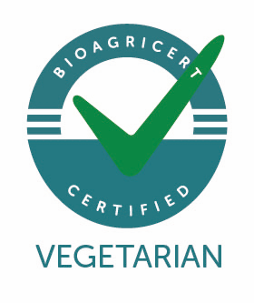 | 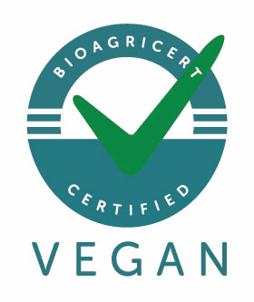
TYPE OF REQUESTED CERTIFICATION

TYPE OF PRODUCTS
Food | Cosmetics | Other:
Feed – Pet Food | Detergents | Other:

TYPE OF ACTIVITY
 | Processing |  | Sale and/or Distribution of Own Brand Products
 | Packaging |  | Catering
 | Labelling |  | Other (specify)
 | Storage |  | Other (specify)

Number Of Production Plants (INCLUDING THE Contractors)

Number of Products/Recipes/Formulations

List the Product Category and/or the Denomination (e.g. Confectionery products: Biscuits, Croissants, etc.)

1 |  | 4
2 |  | 5
3 |  | 6

CONTINUE (indicate or attach a list of products and production plants, if different from the company headquarters):

OTHER CERTIFICATIONS
 | YES/NO | if any, indicate:
Has the company a certified QMS quality management system or other system certifications (e.g. ISO 9001, ISO 14001, Emas, ISO 22000, SA 8000)?
Has the company other product/process service certifications (e.g. Organic production, IFS, BRC, etc.)?
Does the company adhere to other standards and certification marks related to vegetarian, vegan and plant based requirements?

Date

For The Applicant Operator (Name and Family Name)
Once Bioagricert receives this duly completed informative questionnaire, it will process it and send the personalized Fee/Estimate and the Protocol of Agreement/Memorandum of Understanding in order to finalize the contractual relationship.
When the VeganOK trademark is also required, the operator must also sign the contractual conditions with the trademark owner (www.veganok.it).
Subsequently, the requesting operator must send to Bioagricert the documentation necessary for the preliminary document evaluation:
- Certification request
- Recipe/Formulation of the product
- Technical sheets of ingredients and technological aids used
- Veg-vegan-plant based technical report with the description of the production process and the measures adopted in order to meet the applicable requirements of the Standard (supplier qualification, control and acceptance of supplies, prevention of admixture and contamination with products of animal origin, etc.).
The certification process is divided into the following phases:
- Initial evaluation of the products and of the production process, which includes, among other things, the assessment of the composition of the products for which certification is required, as well as the conformity of raw materials through the technical sheets of all components, including additives and technological adjuvants. The applicant company must describe all the working procedures and the separation and cleaning measures adopted in order to prevent any contact and contamination with animal ingredients.
- Inspection at the production plant to ascertain the effective compliance of the products with the vegan requirements of the standard; the correct organization and management of manufacturing processes and internal procedures that could compromise the conformity of the product with the requirements defined in the standard; compliance with relevant environmental and social criteria.
- Issue of the Certificate which shows the list of products judged compliant with the standard and their classification: vegetarian, vegan or plant based.
- Annual surveillance through periodic inspections aimed at confirming the maintenance of compliance conditions. The control plan may also include analyses aimed at investigating the possible presence of ingredients and/or contaminants of animal origin

